& - whats the address

\* - go to that address

* Modern hardware stores pointer as 8bytes.

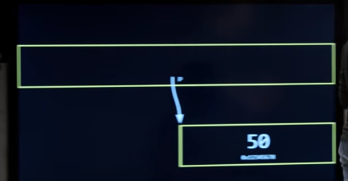

* String is an array of character with \0 at the back.

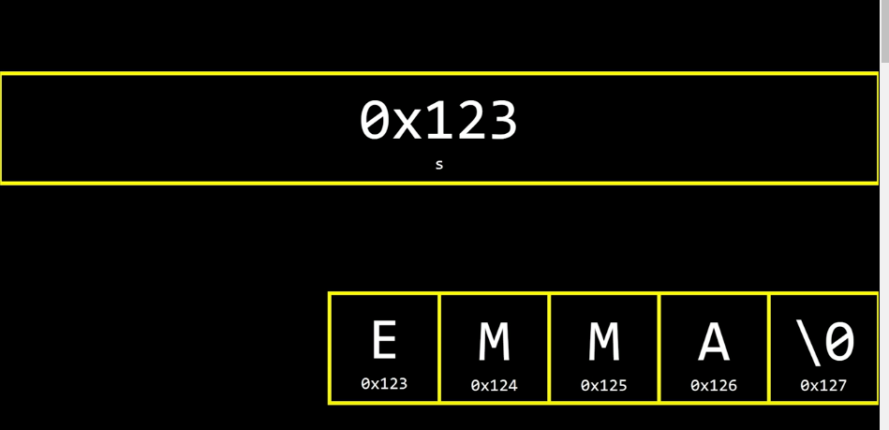

* When you allocate memory, you have to remember to deallocate the memory.
* When putting variables inside the function, you are putting copys of the variables, not the actually variable. So in c, you need to put address of the variables inside the function to have a changing effect to the variable.

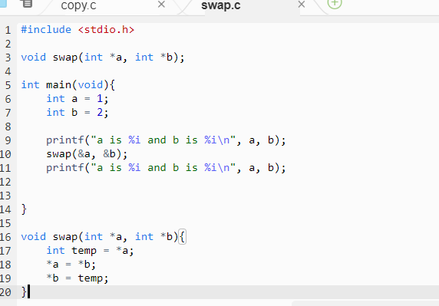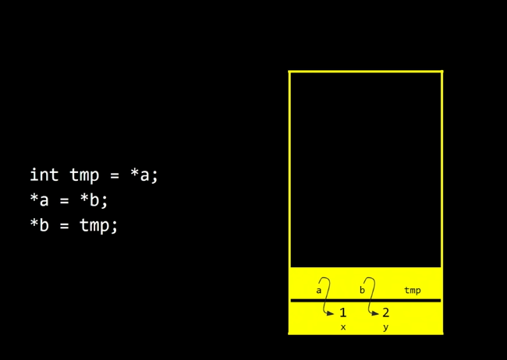

* Function is stored at stack and malloc is stored at heap. When function is called too much, for example a recursive function, an overflow occurs hence the name stack overflow.
* Each pixel is three colors in combination, red green blue
* Colors can be represented using 1 byte(8 bit) per color
* So 3bytes per pixel, 24 bit color

